# Sql-query assignment

## By:- jaimin trivedi

[1]1. Create Table Name : Student and Exam

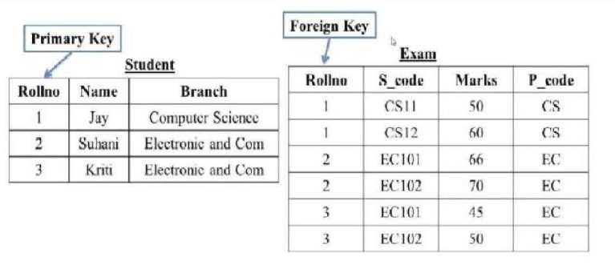

Ans

| Student table | CREATE TABLE Student (  Roll_no INT AUTO_INCREMENT PRIMARY KEY,  name VARCHAR(255) NOT NULL,  branch VARCHAR(255) NOT NULL  ); |
| --- | --- |
| Exam table | CREATE TABLE Exam (  Roll_no INT AUTO_INCREMENT,  s_code int NOT NULL,  mark int ,  p_code VARCHAR(255) NOT NULL,  Foreign KEY (Roll_no) REFERENCES student(Roll_no)  ); |

2. Create table given below: Employee and IncentiveTable

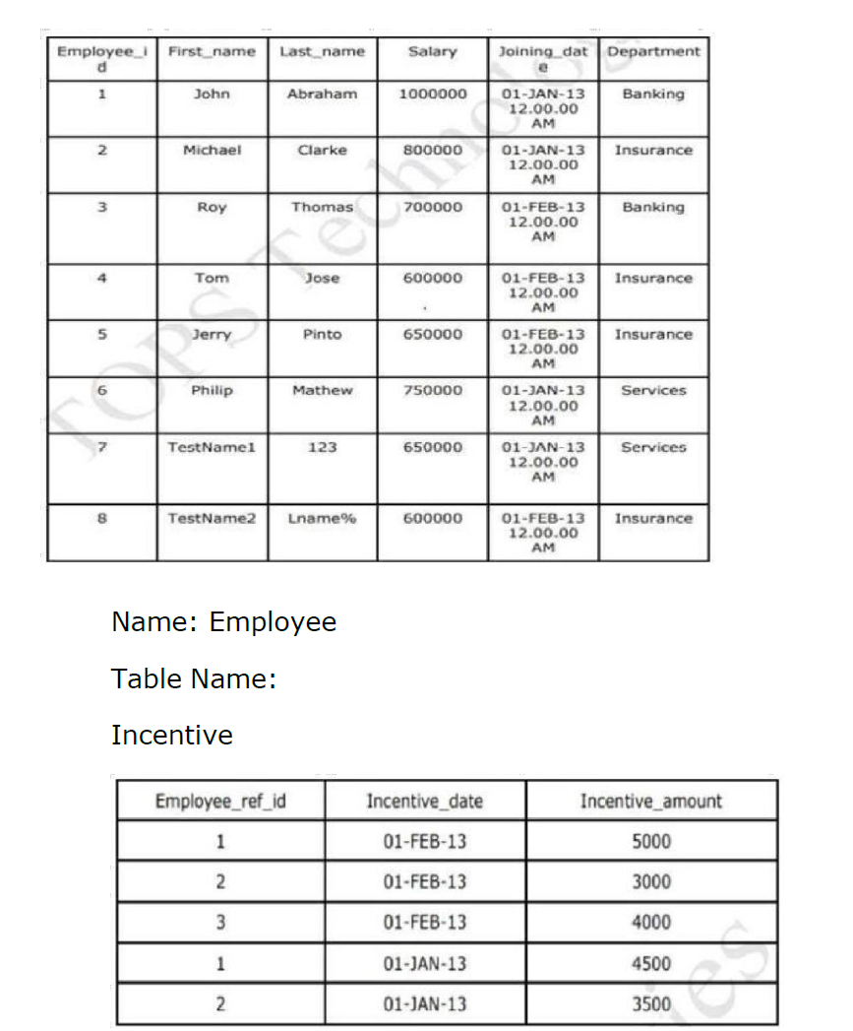

| Employee table  [2]  Incentent table | CREATE TABLE Employee (  Employee_id INT NOT NULL UNIQUE AUTO_INCREMENT,  first_name VARCHAR(30),  last_name VARCHAR(30),  salary INT,  joining_date TIMESTAMP DEFAULT CURRENT_TIMESTAMP NOT NULL,  department VARCHAR(50),  PRIMARY KEY (Employee_id)  );  CREATE TABLE incentive (  Employee_ref_id INT,  incentive_date TIMESTAMP DEFAULT CURRENT_TIMESTAMP NOT NULL,  incentent_amount INT NOT NULL,  FOREIGN KEY (Employee_ref_id) REFERENCES Employee(Employee_id)  ); |
| --- | --- |

| 3. Get First_Name from employee table using Tom name “Employee Name”. | SELECT * FROM `employee` WHERE first_name='tom'; |
| --- | --- |
| 4. Get FIRST_NAME, Joining Date, and Salary from employee table. | SELECT first_name,joining_date,salary FROM employee; |
| 5. Get all employee details from the employee table order by First_Name ascending and Salary descending? | SELECT * FROM `employee`ORDER BY first_name ASC,salary DESC; |
| 6. Get employee details from employee table whose first name contains ‘J’. | SELECT * FROM `employee` WHERE first_name LIKE 'j%'; |
| 7. Get department wise maximum salary from employee table order by  8. salaryascending? | SELECT department, MAX(salary) AS max_salary  FROM employee  GROUP BY department  ORDER BY max_salary ASC; |
| 9. Select first_name, incentive amount from employee and incentives table forthose employees who have incentives and incentive amount greater than 3000 | SELECT e.first_name, i.amount AS incentive_amount  FROM employee e  INNER JOIN incentive i ON e.Employee_id = i.Employee_id  WHERE i.amount > 3000; |

11. Create table given below: Salesperson and Customer

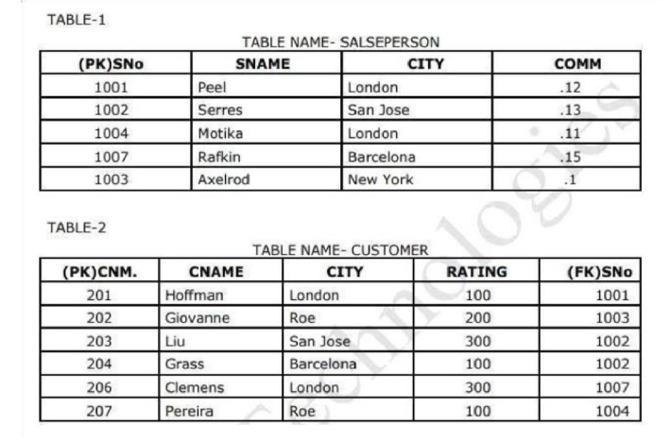

[3]

| Create salesperson table | CREATE TABLE salesperson  (  sno int UNION NOT null,  sname varchar(30),  city varchar(35),  comm float,  PRIMARY KEY (sno)  ); |
| --- | --- |
| Create customer Table | CREATE TABLE customer  (  cno int UNION NOT null,  cname varchar(30),  city varchar(35),  rating int,  sno int    PRIMARY KEY (cno)  FOREIGN KEY (sno) REFERENCES salesperson(sno)  ); |

[4]

| 12. Retrieve the below data from above table  13.All orders for more than $1000. | SELECT *  FROM customer  WHERE ORDER_value > 1000; |
| --- | --- |
| 14.Names and cities of all salespeople in London with commission above 0.12 | SELECT sname , city from salesperson WHERE comm >0.12; |
| 15.All salespeople either in Barcelona or in London | SELECT * FROM salespersom  WHERE city = 'barcelona' or city='london'; |
| 16. All salespeople with commission between 0.10 and 0.12. (Boundary  valuesshould be excluded). | SELECT * FROM salesperson WHERE COMM BETWEEN 0.10 AND 0.12; |
| 17. All customers excluding those with rating <= 100 unless they are located inRome | SELECT * from customer  WHERE rating <= 100 or city = 'rome'; |

18. Write a SQL statement that displays all the information about all salespeople

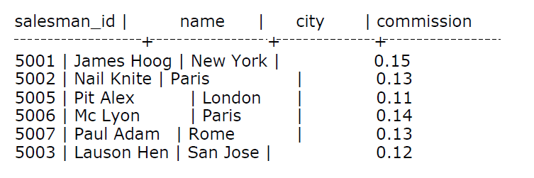

| SELECT * FROM salsepeople |
| --- |

19. From the following table, write a SQL query to find orders that are delivered by a salesperson with ID. 5001. Return ord_no, ord_date, purch_amt.

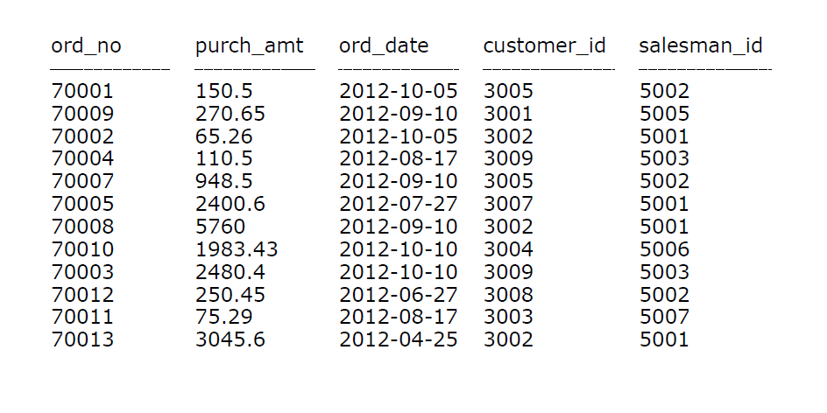

| SELECT ord_no, ord_date , purch_amt  FROM orders  [5]WHERE salesman_id = 5001; |
| --- |

20. From the following table, write a SQL query to select a range of products whose price is in the range Rs.200 to Rs.600. Begin and end values are included. Return pro_id, pro_name, pro_price, and pro_com.

Sample table: item_mast

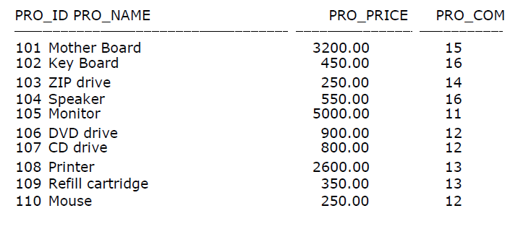

| SELECT pro_id , pro_name , pro_price , pro_com  FROM item_mast  WHERE pro_price BETWEEN 200 AND 600; |
| --- |

21. From the following table, write a SQL query to calculate the average price for a manufacturer code of 16. Return avg.

Sample table: item_mast

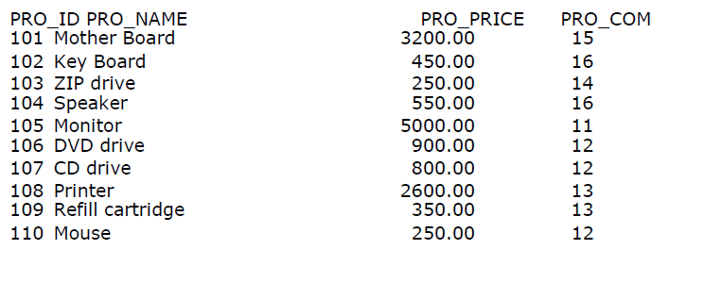

| SELECT AVG (pro_price) as AVG  FROM item_mast  WHERE pro_com = 16; |
| --- |

[6]

22. From the following table, write a SQL query to display the pro_name as 'Item Name' and pro_priceas 'Price in Rs.'

Sample table: item_mast

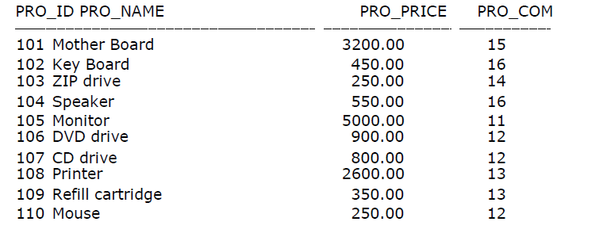

| SELECT pro_name as 'item name',  concat('price in rs .',fromat(pro_price,2))  AS 'price in rs.'  from item mast;  [7] |
| --- |

23. From the following table, write a SQL query to find the items whose prices are higher than or equal to $250. Order the result by product price in descending, then product name in ascending. Return pro_name and pro_price.

Sample table: item_mast

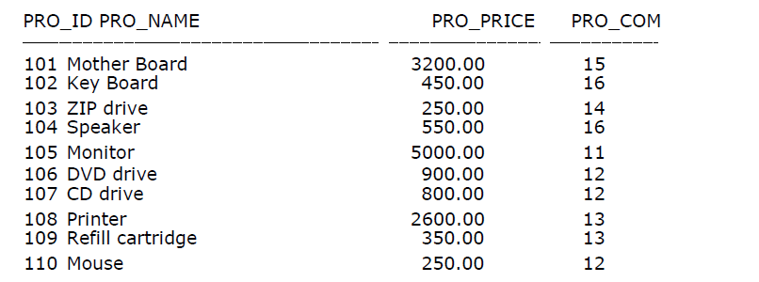

| SELECT pro_name , pro_price  FROM item_mast  WHERE pro_price >=250.00  ORDER BY pro_price DESC , pro_name ASC |
| --- |

1.
2.
3.
4.
5.
6.
7.